80

125

Sample Output 0

7 2 42

10 5 41

1 2 40

5 5 5

4

Sample Input 0

line.

For every box from the input which has a height lesser than 41 feet, print its volume in a separate

Output Format

≤ 100

i

, width

i

, height

i

1 ≤ length

1 ≤ n ≤ 100

Constraints

and height

i

which are length, width and height in feet of the i-th box.

i

- length

i

, width

n lines follow with three integers on each separated by single spaces

The first line contains a single integer n, denoting the number of boxes.

Input Format

tated.

box that can be successfully transported to the other end of the tunnel. Note: Boxes cannot be ro-

through the tunnel only if its height is strictly less than the tunnel's height. Find the volume of each

The height of the tunnel 41 feet and the width can be assumed to be infinite. A box can be carried

characterized by its length, width and height.

Q1) You are transporting some boxes through a tunnel, where each box is a parallelepiped, and is

Week 14

The third box is exactly 41 feet tall, so it cannot pass. The same can be said about the fourth box.

The second box is sufficiently low, its volume is 1 x 2 x 4= = 80.

5 = 125.

The first box is really low, only 5 feet tall, so it can pass through the tunnel and its volume is 5 x 5 x

Explanation 0

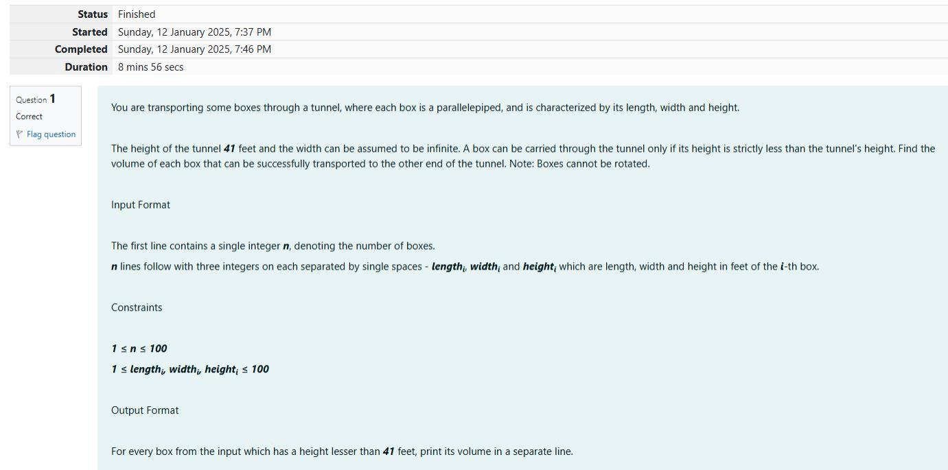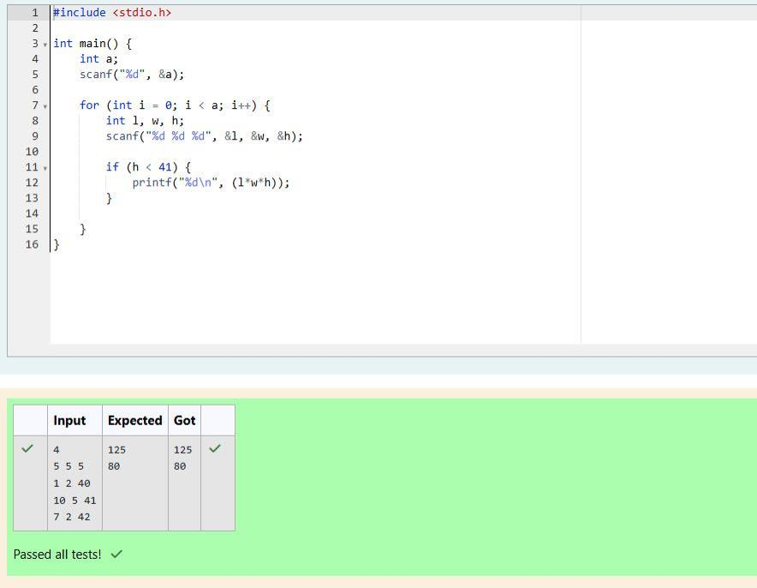

Explanation 0

7 24 25

5 12 13

3 4 5

Sample Output 0

3 4 5

5 12 13

7 24 25

3

Sample Input 0

of the corresponding triangle.

i

and c

i

are a

i

, b

Print exactly n lines. On each line print 3 integers separated by single spaces, which

Output Format

i

+ c

i

> a

i

and b

i

+ c

i

> b

i

> c

i

, a

i

+ b

i

a

≤ 70

i

, b

i

, c

i

1 ≤ a

1 ≤ n ≤ 100

Constraints

rated by single spaces.

on each sepa-

i

and c

i

First line of each test file contains a single integer n. n lines follow with a

i

, b

Input Format

S = Ö p \* (p – a) \* (p - b) \* (p – c) where p = (a + b + c) / 2.

The best way to calculate a volume of the triangle with sides a, b and c is Heron's formula:

different.

sorted by their areas from the smallest one to the largest one. It is guaranteed that all the areas are

. Print them in the same style but

i

and c

i

Q2) You are given n triangles, specifically, their sides a

i

, b

triangle is 6. So the sorted order is the reverse one.

The square of the first triangle is 84. The square of the second triangle is 30. The square of the third

